Database Design Document

VRoom 360

Dev Ghai

October 12, 2011

Revision History

|  |  |  |
| --- | --- | --- |
| **Date** | **Description** | **Changed by** |
| Oct 12, 2011 | Added answers_sequence in answers table to track the order user answers the question in. | Dev Ghai |
| Oct 19, 2011 | Added users_shirtsize in users table to indirectly get shoulder width. | Dev Ghai |
| Nov 2, 2011 | 1. Added errorlog table. 2. Added questions_location_z in questions table 3. Modified data type of questions_location_x, questions_location_y, questions_location_z to float. 4. Added users_email in users table. | Dev Ghai |

# Schemata

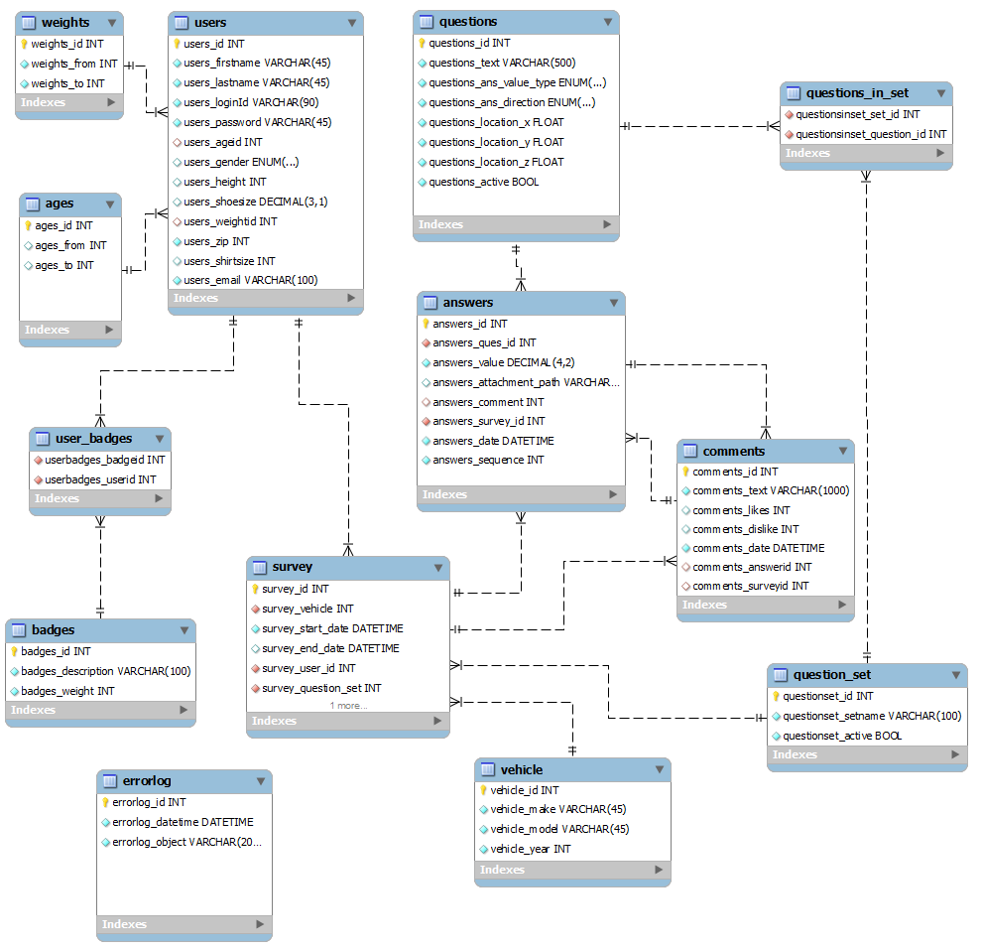

# Summary of Tables

|  |  |  |
| --- | --- | --- |
| Table Name | Description | Ipad needs to sync on every session? |
| Weights | Holds the weight ranges of a person. This is a separate table because depending on the need of the client, they may fine tune the ranges that may be useful for them. This would be application wide and not per survey. | Yes |
| Ages | Holds the age ranges of the person. This is a separate table because depending on the need of the client, they may fine tune the ranges that may be useful for them. This would be application wide and not per survey. | Yes |
| Users | Holds all the information regarding the user that we want. Password field will hold md5 hash of the password string and not the password directly. | Only on profile creation/change. |
| Questions | All the questions that will be asked across all the survey. Should a question be obsolete, we are trying to implement a feature that will allow admin to mark a question as inactive.  To ensure better analytics to data, every question will be marked for higher value being better or lower value being better. | Only on beginning a new survey. |
| Answers | Holds the answers to the questions asked in the survey. Free text comments will be stored in a separate table. Attachments will not be stored directly in database owing to performance considerations. They will be stored on a separate location on server as a file whose path will be stored along with the answer. | Whenever user syncs/completes/pauses the survey. |
| Survey | Hold basic information about the survey. Helps tracking state by noting end date of the survey. Amount of completion can be measured by comparing of questions in the set of questions associated to this survey to number of answers this survey has in the answer table. | Whenever user syncs/completes/pauses the survey. |
| Vehicle | Holds make, model and year of all the cars in the market. If the variable that user wants to enter is not there in this is table, then user should be able to enter it and it should be updated to this table. | Start of survey session. |
| Comments | Holds the free text comment that the user has made. | Whenever user syncs/completes/pauses the survey. |
| Badges | Holds the badges for this survey. They contain description of the badge. The logic/condition for awarding the badge will reside in the server application. | Whenever user syncs/completes/pauses the survey. |
| User_badges | Associates the badges to the user | NA |
| Question_set | Associates survey to a set of questions. There is also a facility to disable the question set. Associating questions to a set will give a lot of flexibility to admins to design a survey and also update the questions even when a few users have not completed it. | NA |
| Questions_in_set | Associates the questions that belong to a set. | NA |
| Errorlog | This table stores the errors happening in the application. Its other purpose is to monitor any attacks on the service. | NA |

# Notes

* Authentication data for the users will be stored locally on iPad to allow offline access.
* Users would need to be online to create a profile to make sure they are not choosing a login id that already exists. Also data needs to be synced to get latest version of the survey they are going to take.

# Conventions

## Naming

|  |  |
| --- | --- |
| Column | <table name>_<column name>  Underscores in table’s name will not appear in column name. |
| Foreign key | fk_<referencing column name>_<referenced column name> |